**Models and their capabilities based on Prompts**

**Prompt for Logo Generation:**

Design a modern logo for 'SolarEasy' with a stylized sun icon made of interlocking arcs in golden-yellow (#FFC312), subtly forming an "S" in negative space. The shape should resemble a rising sun, symbolizing warmth, sustainability, and new beginnings. Pair with a bold sans-serif wordmark in slate gray (#5F6A72) with slight curves. Add earthy green (#006838) accents. Keep the design minimalist, scalable, clean, and suitable for digital and print.

**Prompt for Visual Representation:**

Create a professional infographic slide that represents a solar energy B2B business idea. Include the following labeled sections visually:

* Objective: Help solar panel manufacturers promote to construction companies and real estate developers.
* Vision: Become the top supplier of reliable and affordable solar energy solutions for large-scale buyers.
* Mission: Make it easy for solar makers to reach new clients with clear marketing materials.
* Business Concept: Simple tools like sales emails, product sheets, and cost-saving examples to close B2B deals.
* Target Market: Real estate developers, industrial energy buyers, contractors.
* Value Proposition: Demonstrate savings in money and energy to convince business buyers.
* Target Audience Description: Professionals aged 35–60 in construction, real estate, and energy industries.
* Audience Values: Efficiency, profitability, environmental responsibility.

Use icons, minimalistic charts, solar energy symbols, and clean layout. Use a warm color palette (golden yellow, green, gray). Background should be sleek and modern—like a business presentation slide.

1. **Black Forest Labs (Flux)**

FLUX.1 [dev] is a 12 billion parameter rectified flow transformer capable of generating images from text descriptions.

Logo

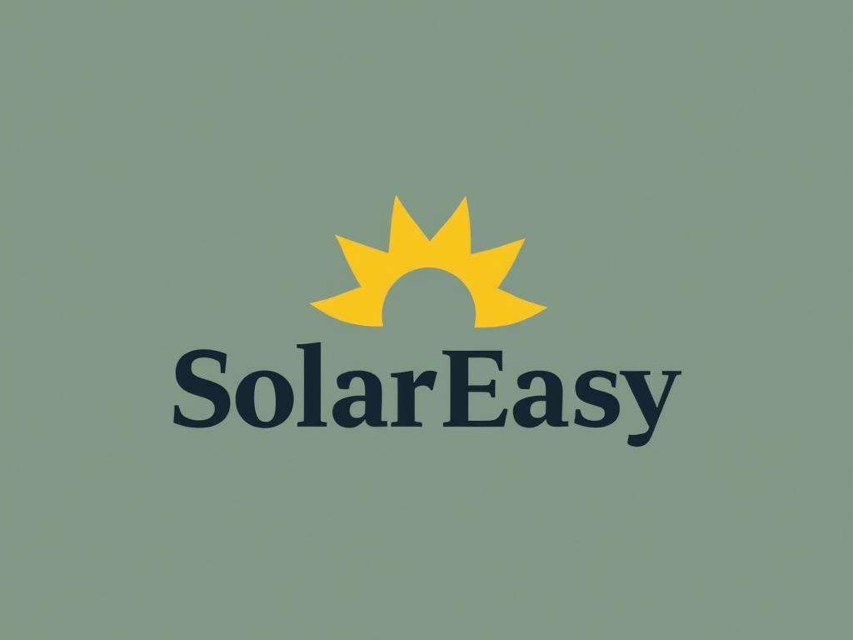

Pictorial Representation

Fails to generate the pictorial representation of prompt.

1. SeaArt.AI

SeaArt is a premier free AI art generator. Dive into a thriving AI content community and explore over 1000k+ models and LoRas. From art to illustrations and paintings, SeaArt effortlessly enhances your creativity.

Logo

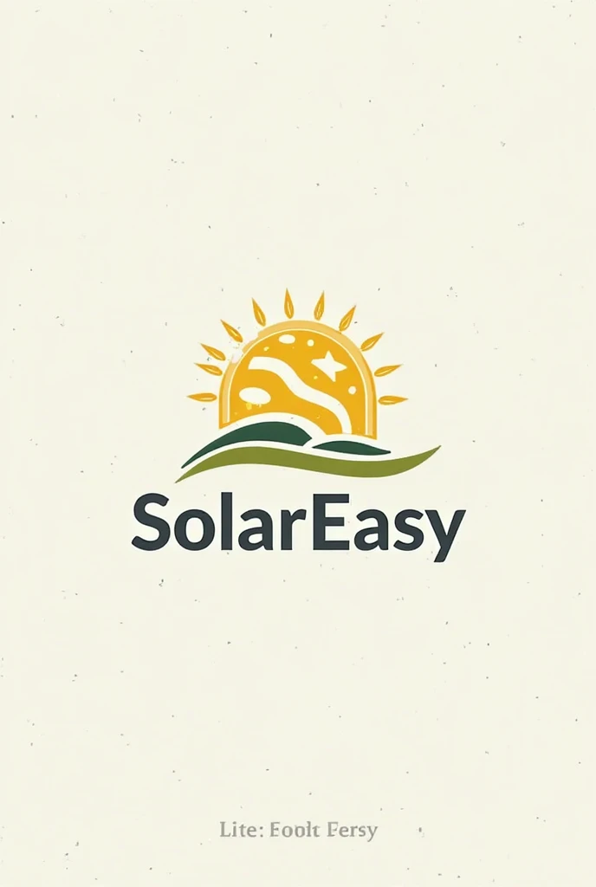

Visual Representation

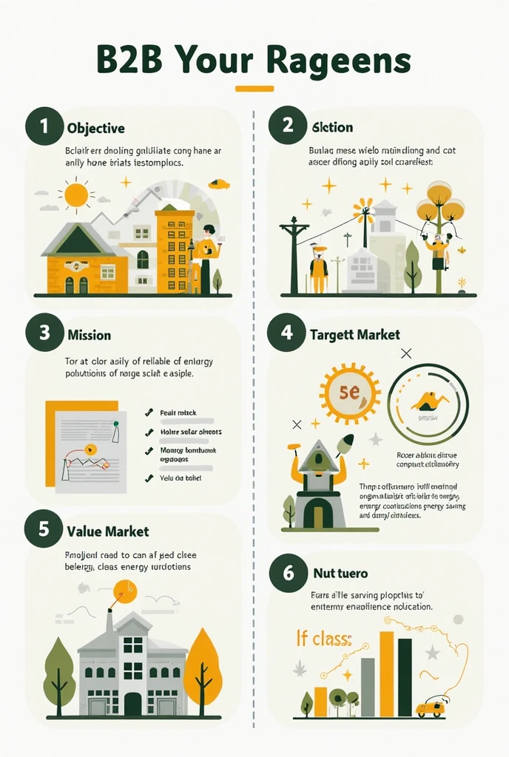

1. Google Imagen4

Google’s best image generation model yet, engineered for creativity. We can use it by Google API KEY.

Logo

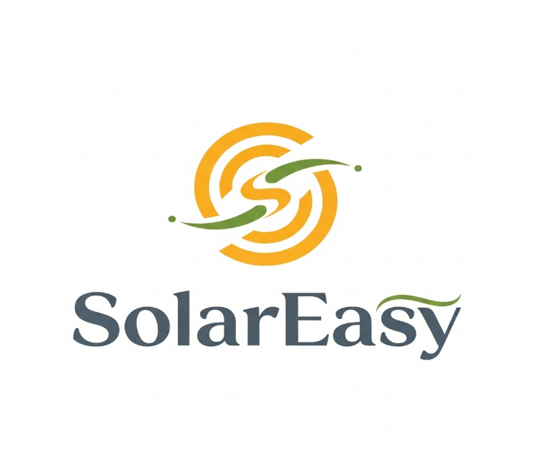

Visual Representation

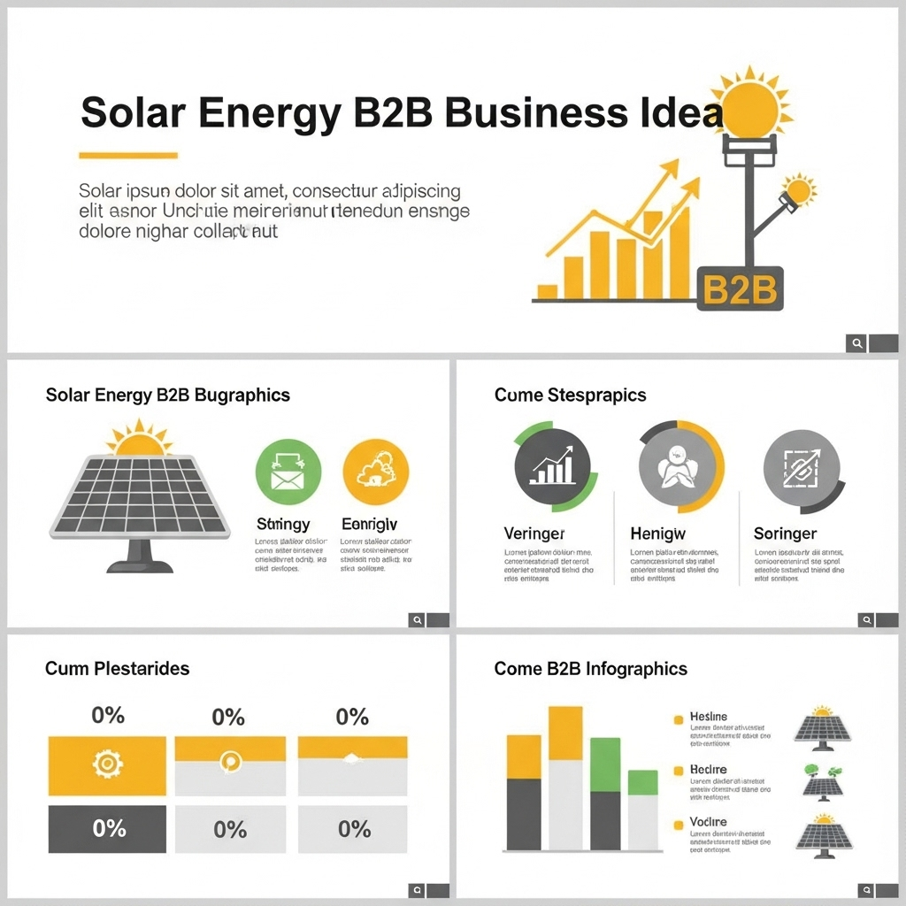

1. Napkin.AI

Napkin turns your text into visuals so sharing your ideas is quick and effective.

Visual Representation

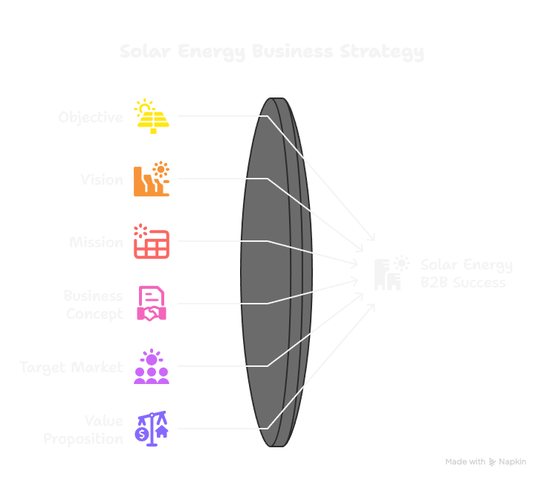

1. Venngage

Create infographics instantly from simple text prompts, turning complex data into clear, engaging visual stories.

Visual Representation

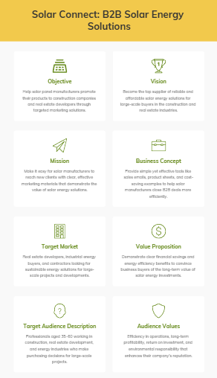

1. ChatGPT

Logo

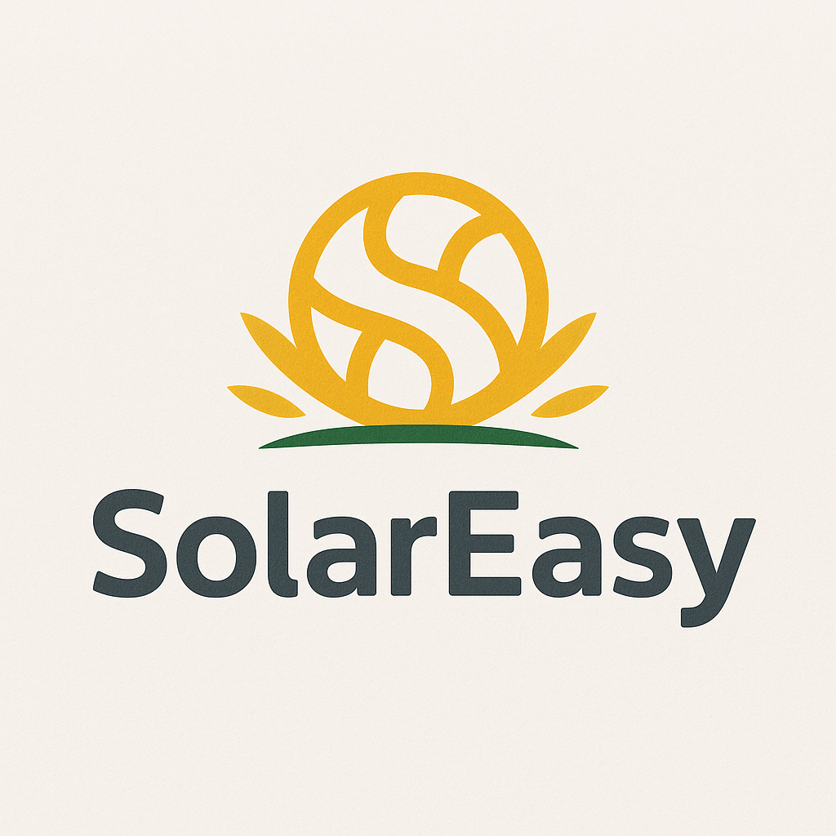

Visual Representation

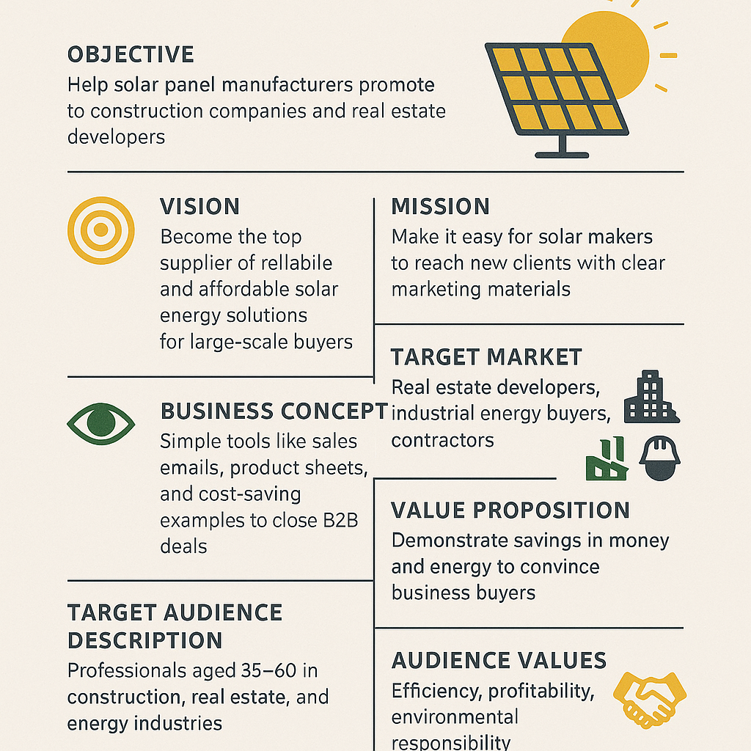

1. Recraft.AI

Using API’s, we can create logos and visual representation of text documents.

Logo

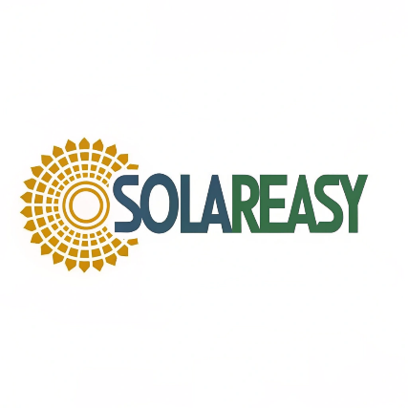

Visual Representation

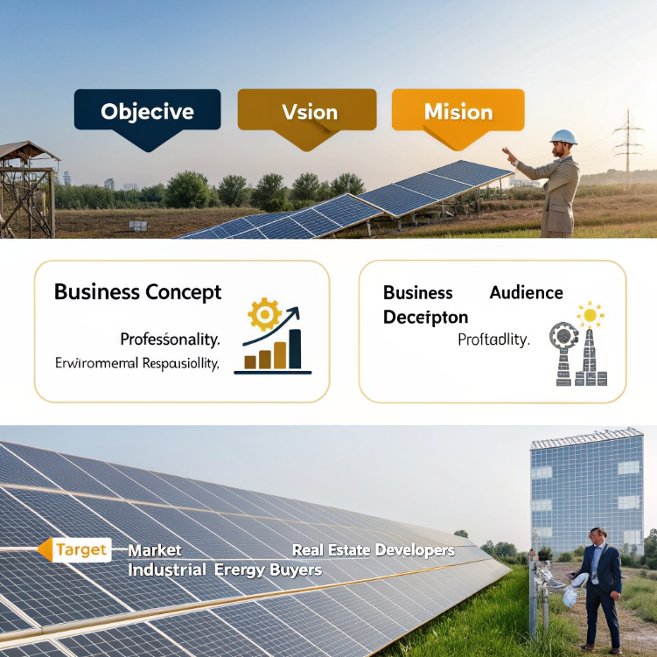

1. Bria.AI

Using API’s, we can create logos and visual representation of text documents.

Logo

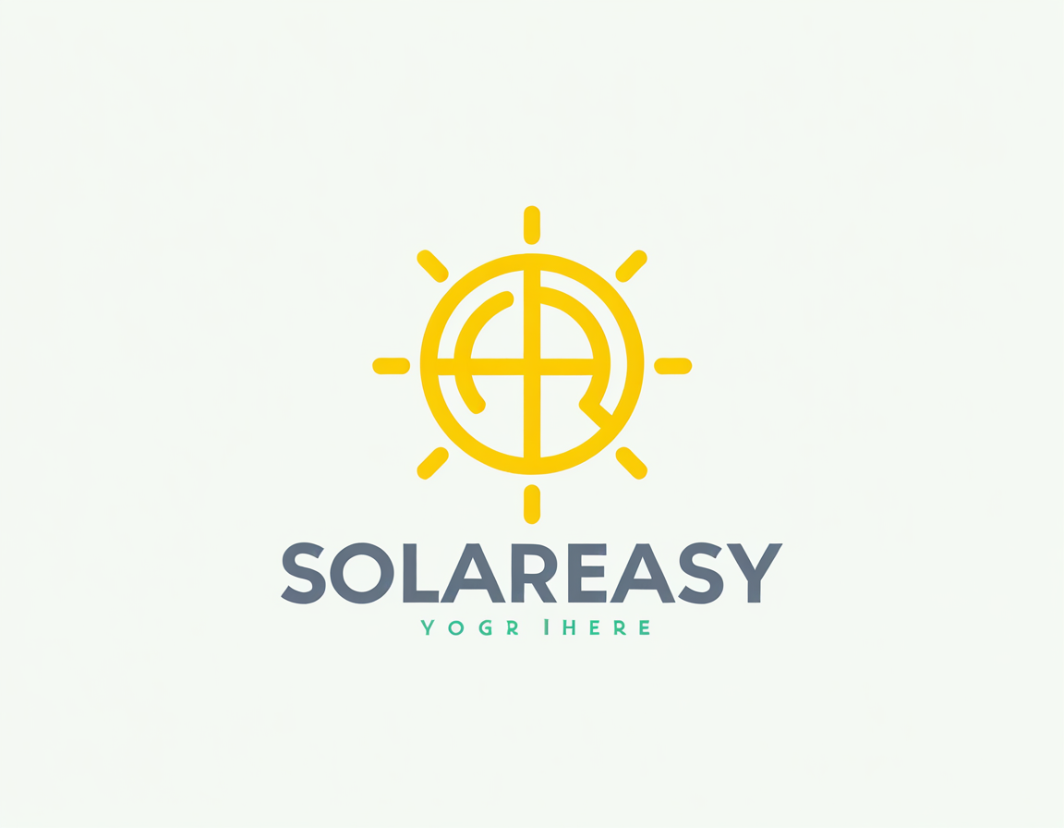

Visual Representation

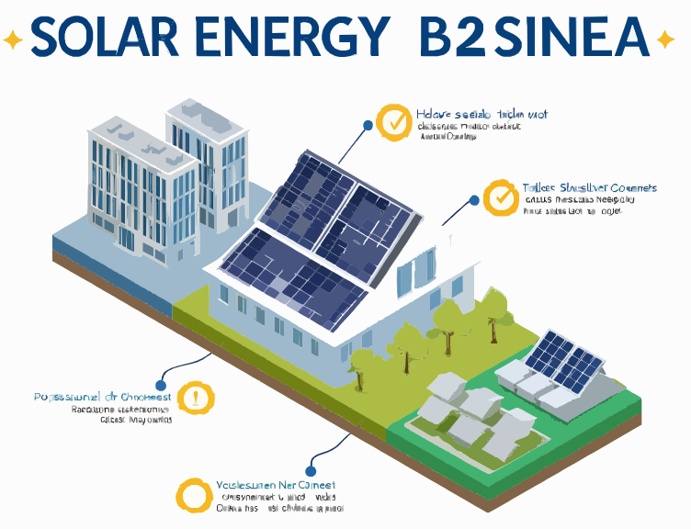

1. GPT Models (LOGO, AI Logo Generator, Glibatree Art Designer)

